Title: Shining City
Year: 2006
Company: Manhattan Theatre Club, Broadway

Shining City
Jan 12 – Feb 17, 2008 in Goodman's Albert Theatre
90 minutes

In a Dublin psychiatrist’s office, a distraught man reveals a fantastical happening: the recent sighting of the ghost of his newly deceased wife. Thus begins this haunting, mysterious tale about two people’s searches for love, meaning and their places in the world.

https://www.goodmantheatre.org/show/shining-city/

Shining City is a celebrated 2004 contemporary Irish play by playwright Conor McPherson that explores guilt, faith, and the supernatural, famously directed on Broadway and at the Goodman Theatre by Robert Falls. [1, 2, 3]
The plot follows Ian, a guilt-ridden former priest who leaves the church to become a therapist in Dublin. His first patient, a distraught widower named John, confesses that he is being haunted by the ghost of his recently deceased wife. As Ian attempts to treat John, he is forced to confront his own personal and spiritual demons, culminating in a gripping psychological and supernatural struggle. [1, 2, 3]
Notable productions connected to Robert Falls include:
- Broadway Premiere (2006): Directed by Falls at the Manhattan Theatre Club's Biltmore Theatre, the production earned two Tony Award nominations, including a nod for Best Play. The cast featured Oliver Platt as John and Brian F. O'Byrne as Ian. [1, 2, 3]
- Chicago Premiere (2008): Falls brought his acclaimed staging back to his home turf at Chicago's Goodman Theatre for a limited run, utilizing a fresh resident cast. [1, 2]
You can explore more production history and learn about Conor McPherson's works via the Manhattan Theatre Club archive or the Internet Broadway Database listing. [1, 2]
https://www.manhattantheatreclub.com/shows/2005-06-season/shining-city/

https://www.manhattantheatreclub.com/shows/2005-06-season/shining-city/See More Productions
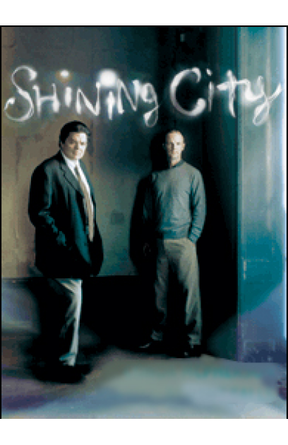
Status: Closed
Theatre: Biltmore
(April 20, 2006 - July 16, 2006 )
- Preview: April 20, 2006
- Open: May 9, 2006
- Close: July 16, 2006
Play - New York Premiere
Running Time: 1hr 30mins
In Dublin a man seeks help from a therapist, claiming to have seen the ghost of his recently deceased wife. What begins as an unusual encounter becomes a struggle between the living and the dead.
For The Record:
“Shining City” had its World Premiere at the Royal Court Theatre in the West End on June 9, 2004.
https://www.nytimes.com/2006/05/10/theater/reviews/shining-city-conor-mcphersons-study-of-loneliness-in-a.html
zhttps://www.theatreinchicago.com/articles/robert-falls-brings-his-acclaimed-broadway-staging-of-shining-city-to-goodman-theatre/305/

- Production Staff
- Opening Night Cast
Theatre Owned / Operated by Manhattan Theatre Club (Lynne Meadow, Artistic Director; Barry Grove, Executive Producer)
Produced by Manhattan Theatre Club (Lynne Meadow, Artistic Director; Barry Grove, Executive Producer)
Originally presented on June 4, 2004 by The Royal Court Theatre and Dublin Gate Theatre
Written by Conor McPherson
Directed by Robert Falls; Assistant Director: Henry Wishcamper
Scenic Design by Santo Loquasto; Costume Design by Kaye Voyce; Lighting Design by Christopher Akerlind; Sound Design by Obadiah Eaves; Associate Scenic Design: Jenny B. Sawyers; Assistant Scenic Design: Wilson Chin; Assistant Costume Design: Sarah Laux; Assistant Lighting Design: Michael J. Spadaro; Assistant Sound Design: Mark Huang
MTC General Manager: Florie Seery; Company Manager: Denise Cooper
Production Stage Manager: Barclay Stiff; MTC Production Manager: Ryan McMahon; Stage Manager: Francesca Russell
Dialect Coach: Deborah Hecht; Casting: Nancy Piccione and David Caparelliotis; MTC Director of Artistic Operations Mandy Greenfield; MTC Director of Development: Jill Turner Lloyd; MTC Director of Marketing: Debra A. Waxman; Press Representative: Boneau / Bryan-Brown; MTC Director of Artistic Development: Paige Evans; MTC Director of Artistic Production: Michael Bush; Photographer: Joan Marcus; Advertising: SPOTCo, Inc.; Press Associate: Jim Byk, Aaron Meier and Heath Schwartz
By Special Arrangement with Scott Rudin, Roger Berlind and Debra Black

Best Play
2006 Nominee

Best Actor in a Play
2006 Nominee
Oliver Platt

Drama Desk Award

Outstanding Actor in a Play
2006 Nominee
Brían F. O'Byrne
Brían F. O'Byrne
Ian
Oliver Platt
John
Martha Plimpton
Neasa
Peter Scanavino
Laurence
Understudies: John Curless (John), Chris Genebach (Ian, Laurence) and Fiana Toibin (Neasa)

https://chicagoreader.com/arts-culture/therapist-heal-thyself/

https://www.broadway.com/buzz/94978/robert-falls-to-helm-conor-mcphersons-shining-city-at-the-biltmore/

https://artsfuse.org/414/theater-review-a-shining-city-on-the-yawning-heights/

Written by: Conor McPherson
Directed by: Robert Falls
Cast: Oliver Platt, Brï¿½an F. Oï¿½Byrne, Martha Plimpton and Peter Scanavino.
Synopsis: Focuses on a guilt-ridden man who visits a therapist after seeing the ghost of his recently deceased wife. What starts out as an everyday exchange becomes a gripping struggle to survive ï¿½ a struggle that will change both men for the rest of their lives.
What the critics had to say.....
BEN BRANTLEY of the NEW YORK TIMES says ï¿½Quiet, haunting and absolutely glorious new play.ï¿½
CLIVE BARNES of THE NEW YORK POST says "We're offered snippets of stories that never quite hang together and never quite make sense. They're presumably meant to illuminate characters which, unfolding before us, provide a meaningful dramatic experience. They don't."
HOWARD KISSELL of the NEW YORK DAILY NEWS says "Despite the wonderful cast and Robert Falls' sensitive direction, 'Shining City' never quite jells."
MICHAEL SOMMERS of the STAR-LEDGER says "An artful, absorbing new drama about two men deeply haunted by their actions."
JACQUES LE SOURD of THE JOURNAL NEWS says "Everything is right about 'Shining City,' Conor McPherson's fantastic new play."
LINDA WINER of NEWSDAY says "The play, recounts clumsy attempts at intimacy by lonely but not especially interesting people."
MICHAEL KUCHWARA of the ASSOCIATED PRESS says "McPherson has written a small, carefully calibrated tale that requires delicate handling. Fortunately, it has been given a scrupulous production by Manhattan Theatre Club."
FRANK SCHECK of the HOLLYWOOD REPORTER says "The interplay between these two troubled souls forms the heart of this alternately amusing and deeply moving work."
External links to full reviews from newspapers
New York Times
New York Post
New York Daily News
Journal News
NewsDay
Associated Press
The Hollywood Reporter
https://www.nytimes.com/2006/05/10/theater/reviews/shining-city-conor-mcphersons-study-of-loneliness-in-a.html

https://www.theatermania.com/news/full-cast-and-creative-team-set-for-shining-city-opening-date-moved-to-may-9_7775/

https://windycitytimes.com/2008/01/30/theater-shining-city/

https://www.sj-r.com/story/bulletin-tab/2008/03/14/theater-review-shining-city-is/65342284007/

https://www.tdf.org/on-stage/tdf-stages/falls-rises/

